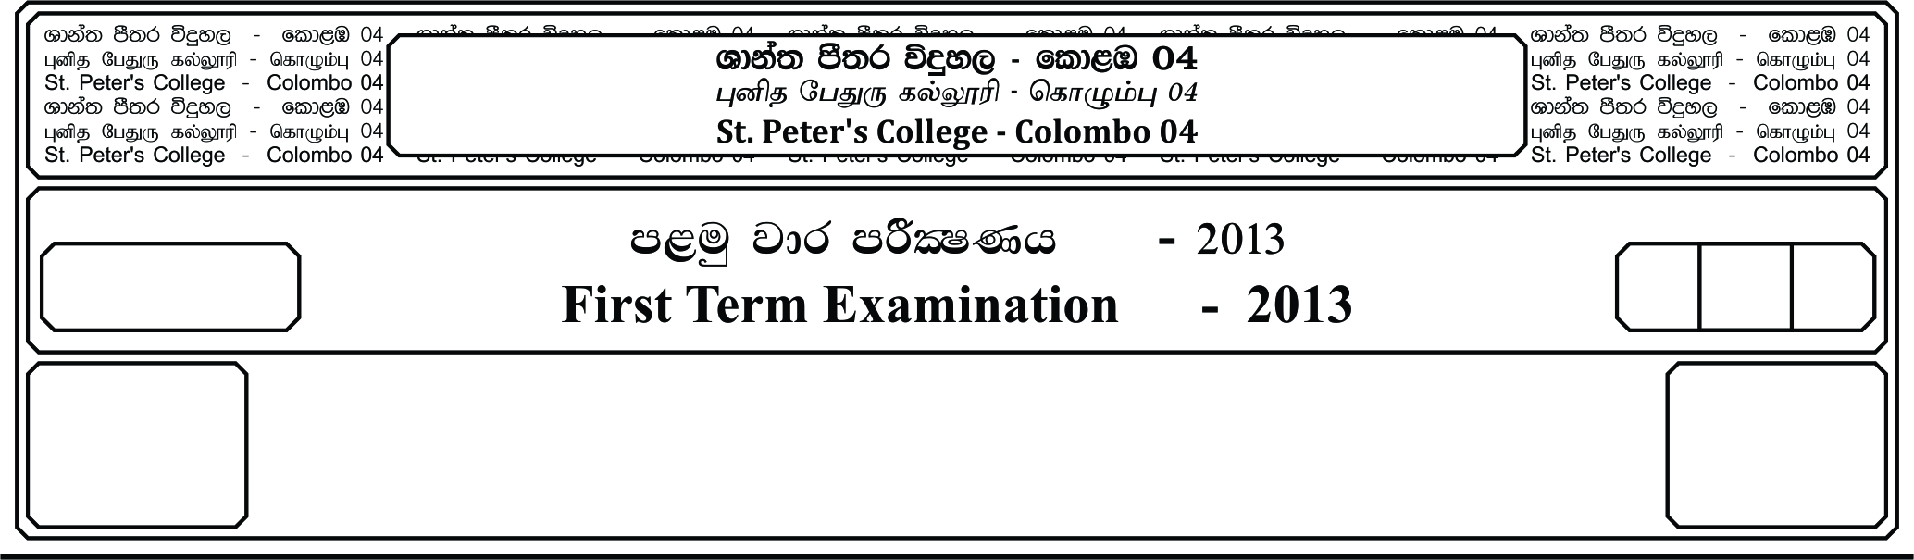

13 fY%aKsh

GRADE 13

E

meh 03

03 Hours

II

**f;jk jdr mÍCIKh - 2020**

**Third Term Examination - 2020**

Âj úoHdj - »»

**BIOLOGY – II**

09

❖ **Instructions**

**-** This question paper consists of 10 questions in 11 pages.

**-** This question paper comprises of part A and part B

**-** The time allocated for both parts is three hours.

**PART A - ( Structured Essay (Page 2-11)**

**-** Answer all four questions on this paper itself.

- Write your answers in the space provided for each question. Note that the space

provided is sufficient for your answers and extensive answers are not expected.

**PART B - (Essay (Page 12 )**

- Answer four questions only.

- Use the papers supplied for this purpose. At the end of the time allocated for this

paper, tie the two parts together so that part A is on the top of part B before

handling over the supervisor.

- You are permitted to remove only part B of the question paper from the

examination hall.

**For Examiners Use Only**

|  |  |  |
| --- | --- | --- |
| **Part** | **Question No** | **Marks** |
| **A** | 1 |  |
| 2 |  |
| 3 |  |
| 4 |  |
| **B** | 5 |  |
| 6 |  |
| 7 |  |
| 8 |  |
| 9  10 |  |
| **Total** |  |  |
| **Percentage** | |  |

**Final Marks**

|  |  |
| --- | --- |
| **Paper I** |  |
| **Paper II** |  |
| **Total** |  |

**Part A – Structured Essay**

★ Answer all 04 questions on this paper itself.

**01. A.** i. What is meant by cellular respiration?

…………………………………………………………………………………………..

…………………………………………………………………………………………..

…………………………………………………………………………………………..

…………………………………………………………………………………………..

ii. Write the balanced chemical equation for aerobic respiration.

…………………………………………………………………………………………..

iii. State the main processes takeplace in first step of aerobic respiration.

…………………………………………………………………………………………..

…………………………………………………………………………………………..

…………………………………………………………………………………………..

…………………………………………………………………………………………..

…………………………………………………………………………………………..

iv. State the importance of NADH in anaerobic respiration.

…………………………………………………………………………………………..

…………………………………………………………………………………………..

…………………………………………………………………………………………..

**B.** i. What are the uses of dichotomous key?

…………………………………………………………………………………………..

ii. Some characteristics of 6 animals which are labeled as P, Q, R, S, T & U are given

below. Question numbers (ii) – (iv) based on them.

P - Possess anterior & posterior suckers with segmented body.

Q - Diploblastic animal, contain many circles of tentacles around mouth.

R - Cylindrical shaped body covered by moist skin, Lay eggs without shells.

S - Possess segmented body with jointed legs have book lungs for respiration.

T - Exclusively marine, possess incomplete digestive system and endoskeleton.

U - Have chitinous exoskeleton and 2 pairs of wings.

ii. Identify animals which are denoted by P, Q, R, S, T & U

P - ………………………….. Q - …………………………..

R - ………………………….. S - …………………………..

T - ………………………….. U - …………………………..

iii. Two of the above animals are belong to same phylum. State the letters of them & write

the phylum

…………………………………………………………………………………………..

…………………………………………………………………………………………..

iv. Using above animals complete following dichotomous key.

1. Having radially symmetrical body ……… _______

Not having radially symmetrical body ……… _______

2. …………………………………. ……… T

…………………………………. ……… _______

3. Possess legs ……… _______

Do not possess legs ……… _______

4 …………………………………. ……… U

…………………………………. ……… _______

5. Having hydrostatic skeleton ……… _______

Do not having hydrostatic skeleton ……… _______

**C.** This question on following diagram

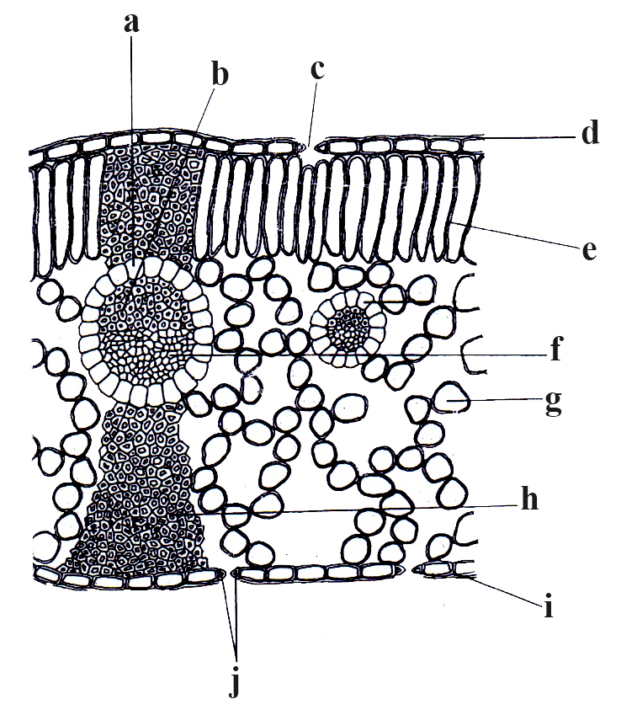

i. Identify the above diagram

…………………………………………………………………………………………

ii. Label the parts denoted by a-j

a - _____________________ b - _____________________

c - _____________________ d - _____________________

e - _____________________ f - _____________________

g - _____________________ h - _____________________

i - _____________________ j - _____________________

iii. State 02 main differences of d & e.

…………………………………………………………………………………………..

…………………………………………………………………………………………..

…………………………………………………………………………………………..

…………………………………………………………………………………………..

iv. State the function of following parts.

b - …………………………………………………………………………………

f - …………………………………………………………………………………

g - …………………………………………………………………………………

i - …………………………………………………………………………………

v. State the unique feature of “f” compaired to other epidermal cells.

…………………………………………………………………………………………..

**02. A.** i. State the location of human stomach.

…………………………………………………………………………………………..

…………………………………………………………………………………………..

…………………………………………………………………………………………..

ii. State 03 main ways which can provide protection to the stomach lining.

…………………………………………………………………………………………..

…………………………………………………………………………………………..

…………………………………………………………………………………………..

iii. a). State the components released by the parietal cells in gastric glands.

…………………………………………………………………………………...

b). State 02 main functios of above mention components.

…………………………………………………………………………………...

…………………………………………………………………………………...

iv. State 03 main hormones which acts on stomach and write the affect of each.

…………………………………………………………………………………………..

…………………………………………………………………………………………..

…………………………………………………………………………………………..

**B.** i. State 02 processes which help to move the lymph through the vessels.

…………………………………………………………………………………………..

…………………………………………………………………………………………..

ii. State 02 functions of lymphatic system of human.

…………………………………………………………………………………………..

…………………………………………………………………………………………..

iii. What is meant by respiratory pigments?

…………………………………………………………………………………………..

…………………………………………………………………………………………..

…………………………………………………………………………………………..

…………………………………………………………………………………………..

iv. Write 03 types of respiratory pigments in annelids.

…………………………………………………………………………………………..

…………………………………………………………………………………………..

…………………………………………………………………………………………..

**C.** i. What is an antigen?

…………………………………………………………………………………………..

…………………………………………………………………………………………..

…………………………………………………………………………………………..

…………………………………………………………………………………………..

ii. State the types of effector cells produced in acquired immunity and write their

functions.

…………………………………………………………………………………………..

…………………………………………………………………………………………..

…………………………………………………………………………………………..

…………………………………………………………………………………………..

iii. What is meant by an active Immunity?

…………………………………………………………………………………………..

…………………………………………………………………………………………..

…………………………………………………………………………………………..

iv. State the type of Immunity which can provided by the body to following situations

a). Tetanus Vaccine - ………………………………….

b). Anti Venom Vaccine - ………………………………….

c). Transfering of antibodies through placenta - ………………………………….

**03. A.** i. Draw a fully labeled diagram of a human nephron.

ii. What is meant by ultra filtration?

…………………………………………………………………………………………..

…………………………………………………………………………………………..

…………………………………………………………………………………………..

…………………………………………………………………………………………..

iii. What are the components which are passively reabsorbed at the site of proximal

convoluted tubule?

…………………………………………………………………………………………..

…………………………………………………………………………………………..

iv. a). What are the parts of uriniferous tubule where aldosterone hormone can acts?

……………………………………………………………………………………….

……………………………………………………………………………………….

b). State the affects of aldosterone hormone on the above mentioned parts.

……………………………………………………………………………………….

……………………………………………………………………………………….

……………………………………………………………………………………….

**B.** i. Briefly explain the nervous organization of phylum Annelida.

…………………………………………………………………………………………..

…………………………………………………………………………………………..

…………………………………………………………………………………………..

…………………………………………………………………………………………..

ii. What are the 03 main phases of action potential?

…………………………………………………………………………………………..

…………………………………………………………………………………………..

…………………………………………………………………………………………..

iii. State the main changes takeplace across the membrane in each phase while mentioning

the reasons.

…………………………………………………………………………………………..

…………………………………………………………………………………………..

…………………………………………………………………………………………..

…………………………………………………………………………………………..

…………………………………………………………………………………………..

…………………………………………………………………………………………..

…………………………………………………………………………………………..

…………………………………………………………………………………………..

…………………………………………………………………………………………..

…………………………………………………………………………………………..

iv. a). What is refractory period?

……………………………………………………………………………………..

……………………………………………………………………………………..

b). State the importance of it.

……………………………………………………………………………………..

……………………………………………………………………………………..

**C.** i. What is meant by an animal hormone?

…………………………………………………………………………………………..

…………………………………………………………………………………………..

…………………………………………………………………………………………..

…………………………………………………………………………………………..

…………………………………………………………………………………………..

ii. State the organs and tissues which contain isolated endocrine cells.

…………………………………………………………………………………………..

…………………………………………………………………………………………..

…………………………………………………………………………………………..

iii. State 02 main examples for hormonal regulating systems operates using positive

feedback mechanism.

…………………………………………………………………………………………..

…………………………………………………………………………………………..

iv. a). State the hormone secreted by the anterior pituitary, which can give non-trophic

effects.

……………………………………………………………………………………..

b). State its functions.

……………………………………………………………………………………..

……………………………………………………………………………………..

……………………………………………………………………………………..

**04. A.** This question based on the following diagram, which represent the gross structure of

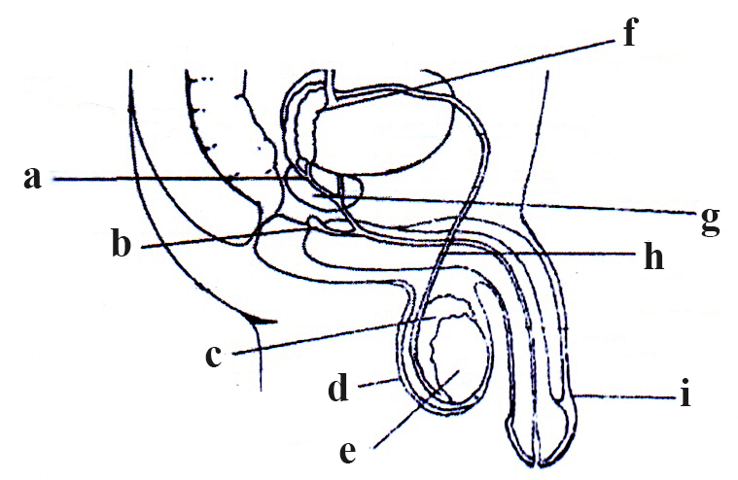 male reproductive system.

i. Labele the parts a - j

a - ………………………….. b - …………………………..

c - ………………………….. d - …………………………..

e - ………………………….. f - …………………………..

g - ………………………….. h - …………………………..

i - ………………………….. j - …………………………..

ii. State 02 functions of “c” & “d”

…………………………………………………………………………………………..

…………………………………………………………………………………………..

…………………………………………………………………………………………..

…………………………………………………………………………………………..

iii. What are the hormones produced by “e” and write the specific type of cell which

produced each hormone.

…………………………………………………………………………………………..

…………………………………………………………………………………………..

iv. a). State the nature of the fluid which secreted by the structure denoted in “f”

……………………………………………………………………………………..

……………………………………………………………………………………..

b). State main components of above secretion.

……………………………………………………………………………………..

……………………………………………………………………………………..

……………………………………………………………………………………

**B.** i. a). What is meant by fontanelles?

……………………………………………………………………………………..

……………………………………………………………………………………..

b). State main function of fontanelles?

……………………………………………………………………………………..

……………………………………………………………………………………..

ii. State 02 main processess found in mandible of human skull and write the main function

of each.

…………………………………………………………………………………………..

…………………………………………………………………………………………..

…………………………………………………………………………………………..

iii. a). State 02 unique features of atlas vertebra compaired to other cervical vertebra.

……………………………………………………………………………………..

……………………………………………………………………………………..

b). State one common feature for all cervical vertebra.

……………………………………………………………………………………..

iv. State 03 main types of joints in the human skeletal system and give one example for

each.

…………………………………………………………………………………………..

…………………………………………………………………………………………..

…………………………………………………………………………………………..

**C.** i. a). What is meant by dihybrid cross?

……………………………………………………………………………………..

……………………………………………………………………………………..

b). State the aim of the Mendel’s dihybrid cross experiment.

……………………………………………………………………………………..

……………………………………………………………………………………..

★ Question numbers ii-iv based on following multificational cross.

A trihybrid cross for seed colour, seed shape and flower colour is given below.

Y - Dominant allele for yellow seed y - recessive allele for green seed

R - Dominant allele for round seed y - recessive allele for wrinkeled seed

C - Dominant allele for colour petals c - recessive allele for white coloured petals

Genotypes of the parental plants used for this trihybrid cross is YyRrCc and yyRrCc. This

crossing has resulted 640 plants in the F1 generation.

ii. Find the probabilities for each monhybrid cross.

…………………………………………………………………………………………..

…………………………………………………………………………………………..

…………………………………………………………………………………………..

…………………………………………………………………………………………..

…………………………………………………………………………………………..

iii. Find the probabilities of exhibiting only two dominant characters.

…………………………………………………………………………………………..

…………………………………………………………………………………………..

…………………………………………………………………………………………..

…………………………………………………………………………………………..

…………………………………………………………………………………………..

…………………………………………………………………………………………..

…………………………………………………………………………………………..

…………………………………………………………………………………………..

…………………………………………………………………………………………..

iv. Find the number of plants expected to exhibit all three dominant characters.

…………………………………………………………………………………………..

…………………………………………………………………………………………..

…………………………………………………………………………………………..

…………………………………………………………………………………………..

**Part B - Essay**

Answer four questions only.

05. a). Briefly explain the structure of the DNA molecule.

b). Explain the functions of major enzymes and other proteins required in DNA replication.

06. a). Explain the structure of the human ovary.

b). Explain the ovarian cycle of human

07. Explain the internal defenses of Innate immunity occur in human body.

08. Explain the life cycle of ***Nephrolepis*** while mentionaing their terrestrial adaptations.

09. a). What is meant by homeostasis?

b). Describe the homeostatic regulation of blood glucose level in human.

10. Write short notes.

a). Hybrid breeding

b). Functions of human skin

c). Sliding filament theory